HIGHER EDUCATION COURSE

STUDY DAYS ON VENETIAN GLASS
Venetian Glass in France and England and its influence in their glass production

Istituto Veneto di Scienze, Lettere ed Arti
16 – 18 September 2025

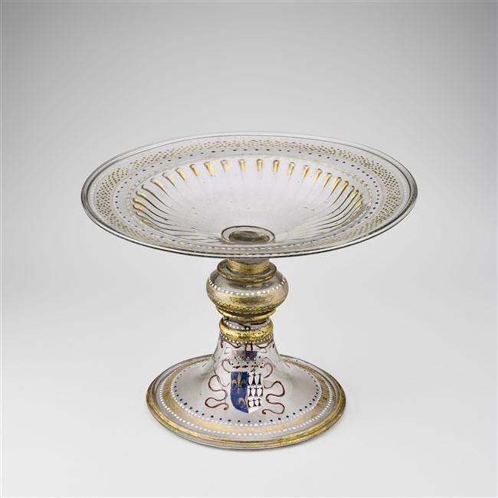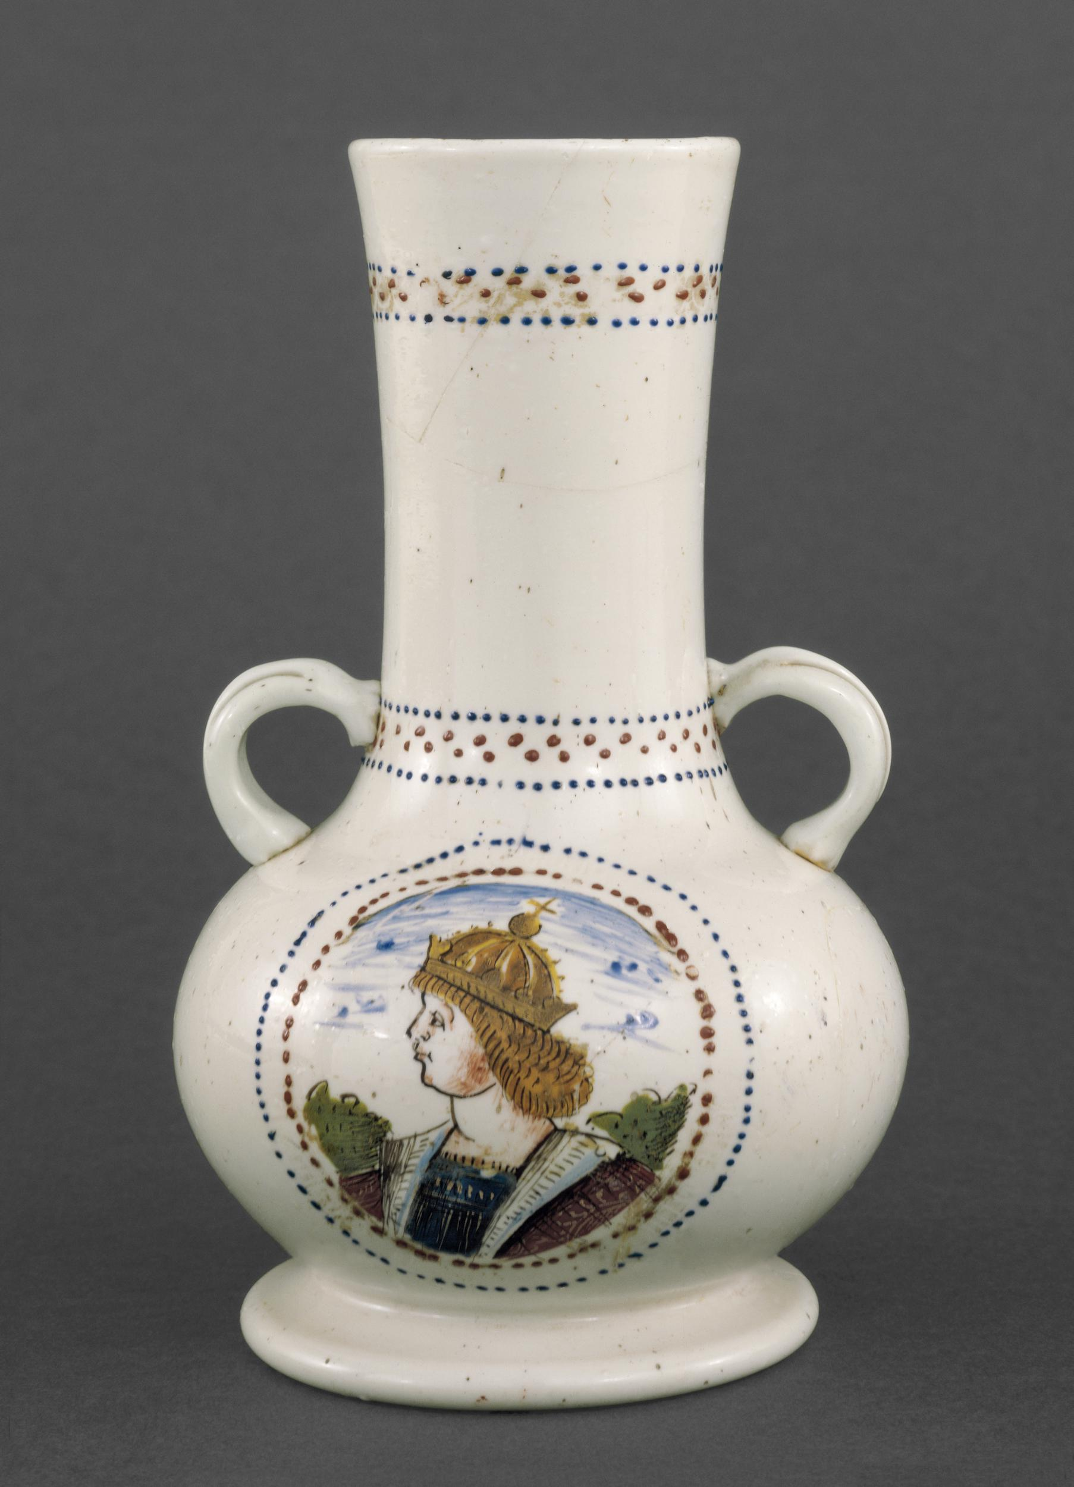

Fig. 1 - Standing cup with Anne de Bretagne coat of arms, Venice, 1499-1514 © Grand Palais RNM (Musée de la Renaissance, château d’Ecouen)/Mathieu Rabeau.
Fig. 2 - Lattimo vase with a portrait of Henry VII, Venice, 1504-1508© The Trustees of the British Museum.

With the support of:
The Corning Museum of Glass
Ecole du Louvre
Fondazione Musei Civici Venezia
LE STANZE DEL VETRO
Venice Foundation
Victoria & Albert Museum

Organised with the collaboration of:
AIHV- Association Internationale pour l’Histoire du Verre- Comitato Nazionale Italiano
Museo del Vetro-Fondazione Musei Civici Venezia

The “Study Days on Venetian Glass” are an opportunity for the in-depth study of Venetian glass and are geared towards an audience of glass scholars, museum curators, conservators, scientists and collectors.
The program includes lectures by art historians and glass experts. All the participants are invited to present the results of their studies and research on this subject. Every lecture is followed by a discussion. Lectures and discussions will be held in English.

The theme of 2025’s edition is:
Venetian Glass in France and England and its influence in their glass production.

In Renaissance times, Venetian glass vessels were exported to France and England, through naval convoys, organized by the Serenissima, called mude, or via Florentine merchant banking companies. These were also sent as diplomatic gifts. Sometimes they were commissioned by the royal family and wealthy upper classes. Among the glass items sent to France, the ones enamelled with the coat of arms of the queen of France, Anne de Bretagne (1499-1514), stand out, as for those shipped to England, the white opaque glass vase with the portrait of the king Henry VII and his device, is among the few rare enamelled lattimo vessels of the early 16th century.
Archive documents and inventories attest the presence of different types and techniques of Venetian glass items sent to these countries, including some that were designed following the taste and shapes much in fashion in France and England.
In the second half of the 16th century, in London, glass items à la façon de Venise began to be in production, also in virtue of the arrival of Murano glassmakers notably of Jacopo Verzelini. Later, England developed its own specific glass industry due also to the work of George Ravenscroft and his lead - crystal glass.
In the 16th and 17th centuries Venetian glass influenced the production of French glassmakers who developed their own style and production of artefacts, including several particular enamelled glass vessels which were also exported to some European countries, such as England.

The topics that will be touched upon will include:

General overview of the history and art history of glass with a focus on Venetian, English and French glass vessels; raw materials and casting/processing techniques; Archaeometry; Conservation and Restoration; discussion about individual pieces in museum collections; archaeological finds; recovery techniques and ancient models during the nineteenth century.

As usual the lectures will be published in English by the Istituto Veneto di Scienze, Lettere ed Arti.

We are glad to announce that the theme of 2026’s edition will be:
Venetian Glass in Flanders and Netherlands.

Scientific Committee

Rosa Barovier Mentasti, Glass historian
Sandro Franchini, Istituto Veneto di Scienze, Lettere ed Arti
William Gudenrath, The Corning Museum of Glass
Lorenzo Lazzarini, Istituto Veneto di Scienze, Lettere ed Arti
Lino Tagliapietra, Artist and glass master
Cristina Tonini, Glass historian
Marco Verità, Independent scholar

Secretariat

Laura Padoan
laura.padoan@istitutoveneto.it

Teaching Staff

Rosa Barovier Mentasti
DA DEFINIRE
Wiilliam Gudenrath
Cristina Tonini
Marco Verita’

How to enroll:

Applications should be sent by e-mail (laura.padoan@istitutoveneto.it) at the latest by 9th May 2025.
Applications should include a CV highlighting the applicant’s interest for the topic and any other previous studies in this specific field.
Applications will be reviewed by the Scientific Committee who will select participants based on their qualifications and their stated motivations. The selection made will attempt to ensure the participation of candidates from different cultural backgrounds and countries of origin. Participants must be committed to take part in all courses, seminars and visits scheduled. At the end of the course, participants will receive a certificate of participation.
The number of places available is limited to 30.
The enrolment fee is 300 €.
All expenses relating to travel to and from Venice, and food and lodgings on arrival, will be borne by participants. The organisers will cover the costs of the trip to Murano and the tour of the Glass Museum, in addition to the demonstrations in there.

Programme of the 2024 Study Days
https://www.istitutoveneto.it/flex/cm/pages/ServeBLOB.php/L/IT/IDPagina/2036

